Życie Komponentu

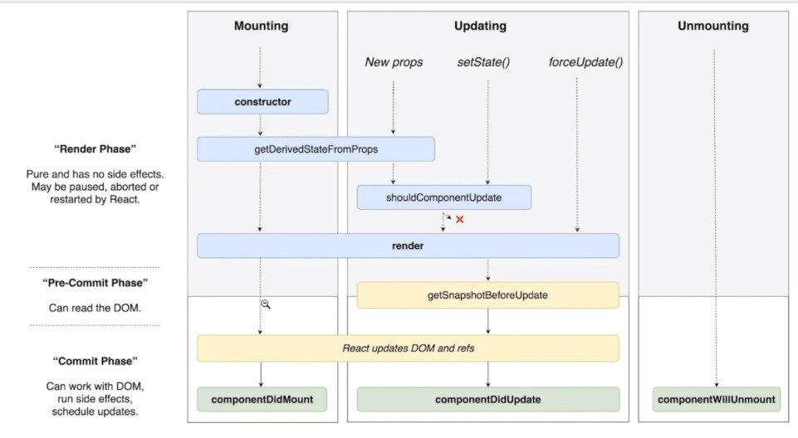
render()  constructor()  MONTOWANIE  „MOUNT”  medoty :  componentWillMount()  compnentDidMount()  ODŚWIEŻANIE  „UPDATE”  medoty :  componentWillReceiveProps()  shouldComponentUpdate()  componentWillUpdate()  componentDidUpdate()  DEMONTOWANIE  „UNMOUNT”  medoty :  componentWillUnmount()  Component call back  EXAMPLE : | 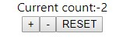  //App.js  import React, { Component } from 'react';  import './App.css';  class App extends Component {  state = {};  componentWillMount(){  this.setState({  count: 0  });  }  increseCounter = () => {  this.setState({  count: this.state.count + 1,  });  };  decrementCounter = () => {  this.setState({  count: this.state.count - 1,  });  };  resetCounter = () => {  this.setState({  count: this.state.count = 0,  });  };  render() {  return (  <div className="App">  <div> Current count:{this.state.count}</div>  <button onClick={this.increseCounter}>+</button>  <button onClick={this.decrementCounter}>-</button>  <button onClick={this.resetCounter}>RESET</button>  </div>  );  }  }  export default App;

